**Project**

**Student Enrollment in PHP with source code**

**INTRODUCTION**

The Student Enrollmentin PHP is a simple mini project for keeping records of students. The project contains the admin and user sides. The admin can manage all the management like adding student’s details, editing the details if required, and view the enrolled student’s information. Admin has an important role in themanagement of this system.

For the user side, a user can view the particular students details who are enrolled in different classes. This project is a simple project that makes a convenient way for any educational organization to keep the records of their students.

#### **About System**

Student Enrollment is in PHP, javascript, and CSS. Talking about the features of this system, it contains the Admin and user sections. From here, the admin can view all the records of the enrolled students. Also, you can edit or delete any details as per the requirements.

The design of this project is pretty simple so that the user won’t find any difficulties while working on it. This Student Enrollment in PHP helps in easy management of various records of the students.

#### **How To Run The Project?**

To run this project, you must have installed a virtual server i.e XAMPP on your PC (for Windows). This Student Enrollment is in PHP with source code is free to download.

After Starting Apache and MySQL in XAMPP, follow the following steps.

***1st Step:*** Extract file  
***2nd Step:*** Copy the main project folder  
**3rd Step:**Paste in xampp/htdocs/

**4th Step:** Open a browser and go to URL “http://localhost/phpmyadmin/”  
***5th Step:*** Then, click on the databases tab  
***6th Step:*** Create a database naming “student” and then click on the import tab  
**7th Step:** Click on browse file and select “student.sql” file  
**8th Step:** Click on go.

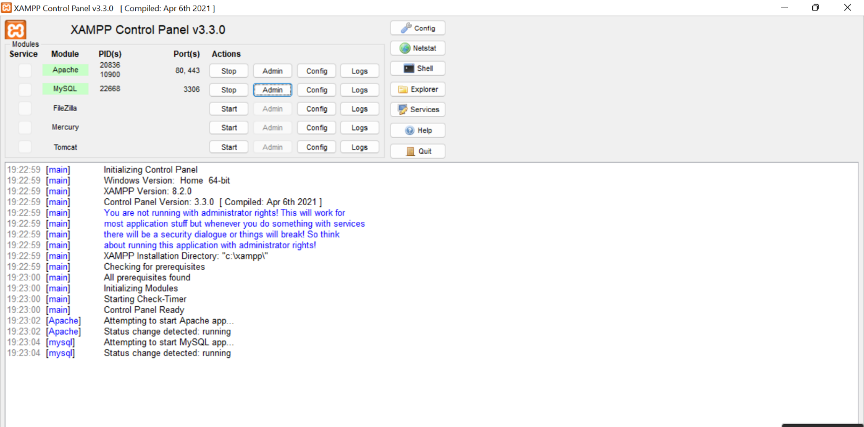

**Fig: Starting the xampp**

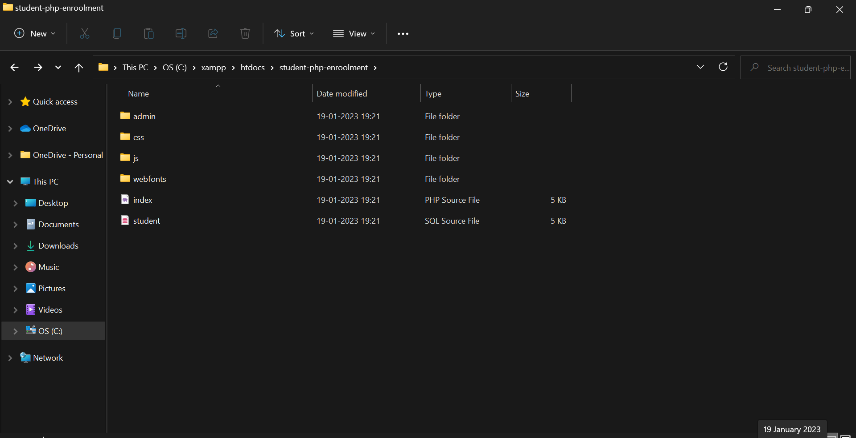

**Fig:** **Importing student-php-enrollment into htdocs**

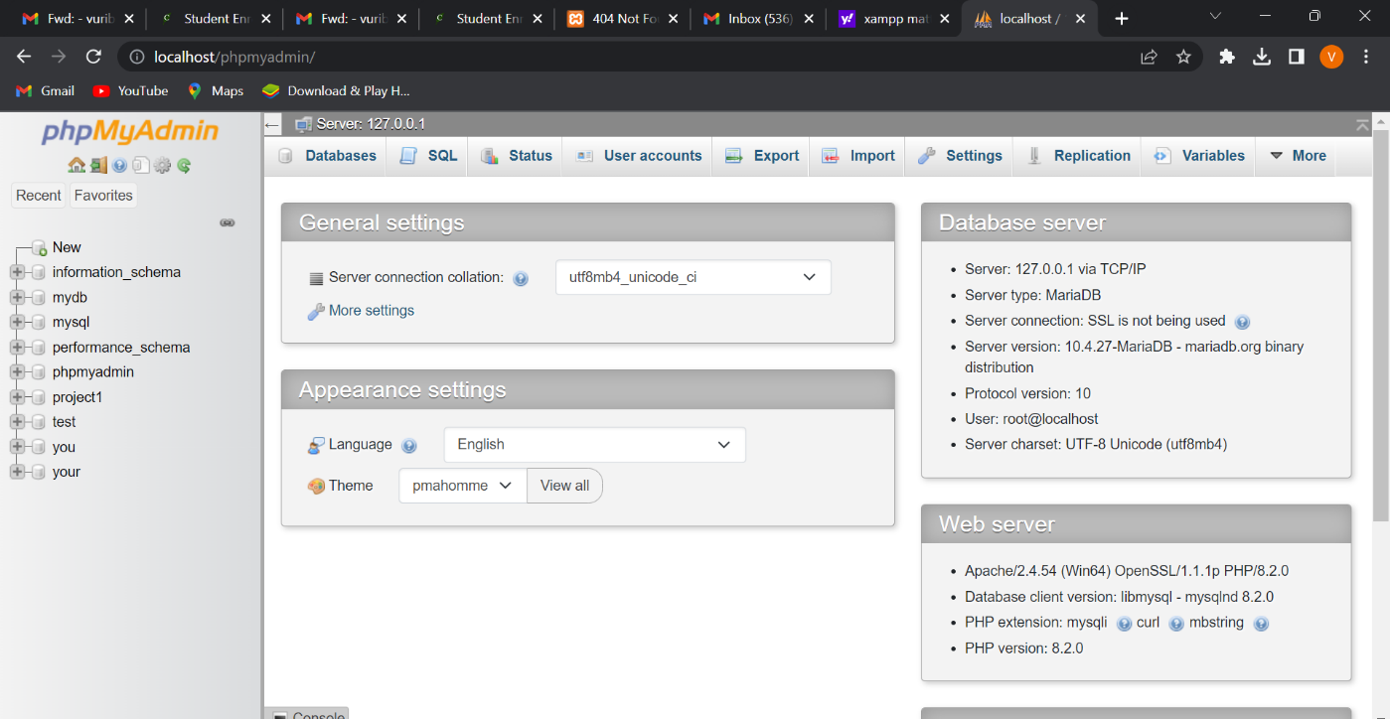

**Fig: Go to phpMyAdmin page**

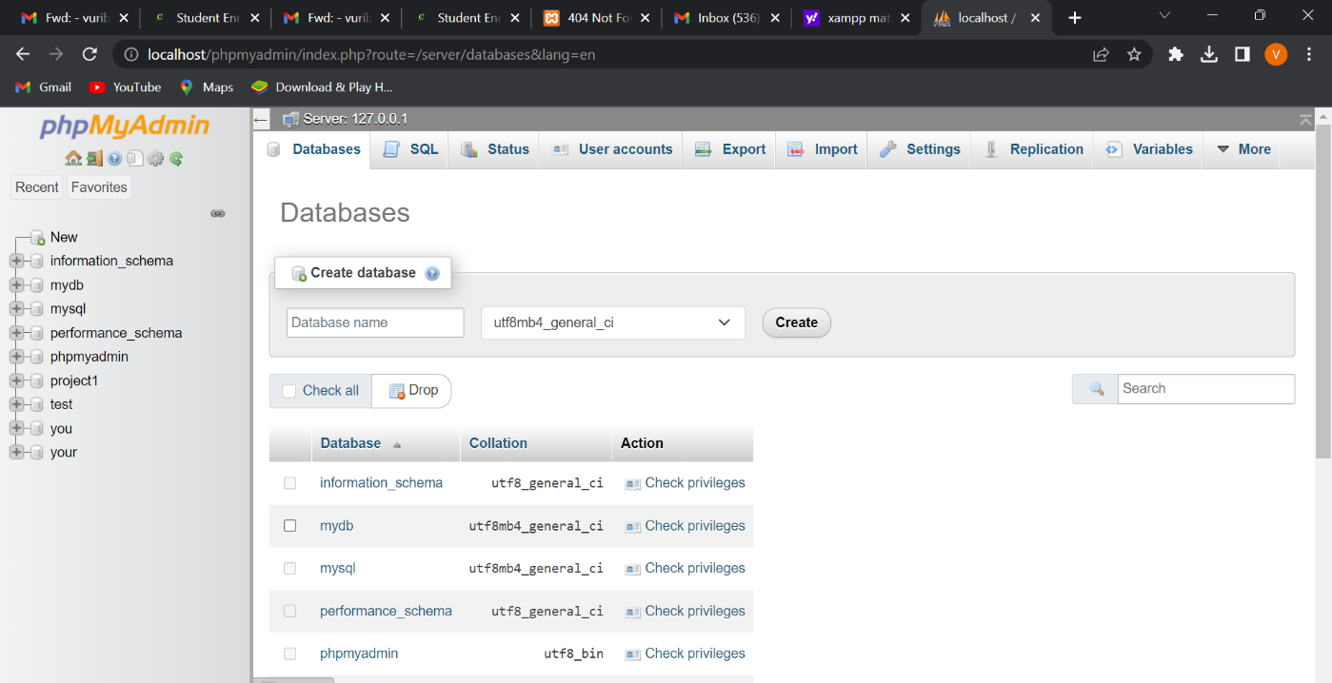

**Creating a database**

* We will create a database namely project1 and whatever code we are running we will import it.
* Then we will create tables namely student-info and user tables from student.sql source file.
* Now we will create tables .

**User table code:**

**Creating a table:**

CREATETABLE `users` (

  `id`int(5) NOT NULL,

  `name`varchar(50) NOT NULL,

  `email`varchar(50) NOT NULL,

  `username`varchar(50) NOT NULL,

  `password`varchar(100) NOT NULL,

  `photo`varchar(50) NOT NULL,

  `status`varchar(12) NOT NULL,

  `datetime`timestampNOT NULLDEFAULTcurrent_timestamp()

**Inserting the data into user table:**

INSERT INTO`users` (`id`, `name`, `email`, `username`, `password`, `photo`, `status`, `datetime`) VALUES

(10, 'Ajharul Islam', 'dedke@gmail.com', 'sdsdq232323', '1bbd886460827015e5d605ed44252251', 'sdsdq2323ee23.jpg', 'inactive', '2020-06-08 11:49:10'),

(14, 'Majhar Rakib', 'ded222ke@gmail.com', 'yescablessdwwewe', '618e02fc80fa3a0bd41d65f5b54a11fc50426d12', 'yescablessdwwewe.jpg', 'inactive', '2020-06-08 11:49:10'),

(15, 'Ajharul Islam', 'sdsdsdsdsdsd@gmail.com', 'mdrashed38', '618e02fc80fa3a0bd41d65f5b54a11fc50426d12', 'mdrashed38.jpg', 'inactive', '2020-06-08 11:49:10'),

(16, 'Ajharul Islam', 'rajrashed42s1@gmail.com', 'yescablessasasas', '618e02fc80fa3a0bd41d65f5b54a11fc50426d12', 'yescablessasasas.jpg', 'inactive', '2020-06-08 11:49:10'),

(17, 'Ajharul Islam', 'rajrashed42sdsd1@gmail.com', 'yescables133232323', '618e02fc80fa3a0bd41d65f5b54a11fc50426d12', 'yescables133232323.jpg', 'inactive', '2020-06-08 11:49:10'),

(18, 'Ajharul Islam', 'djforhad@gmail.com', 'rasheddd', '618e02fc80fa3a0bd41d65f5b54a11fc50426d12', 'rasheddd21-06-20-06-2020steo.jpg', 'active', '2020-06-08 11:49:10'),

(19, 'kus', 'kus@gmail.com', 'kus12345', '1f82ea75c5cc526729e2d581aeb3aeccfef4407e', 'kus12345.jpg', 'inactive', '2020-06-08 11:49:10'),

(20, 'Ajharul Islam', 'janatakumar@gmail.com', 'kumarkosl', '618e02fc80fa3a0bd41d65f5b54a11fc50426d12', 'kumarkosl.jpg', 'inactive', '2020-06-08 11:49:10');

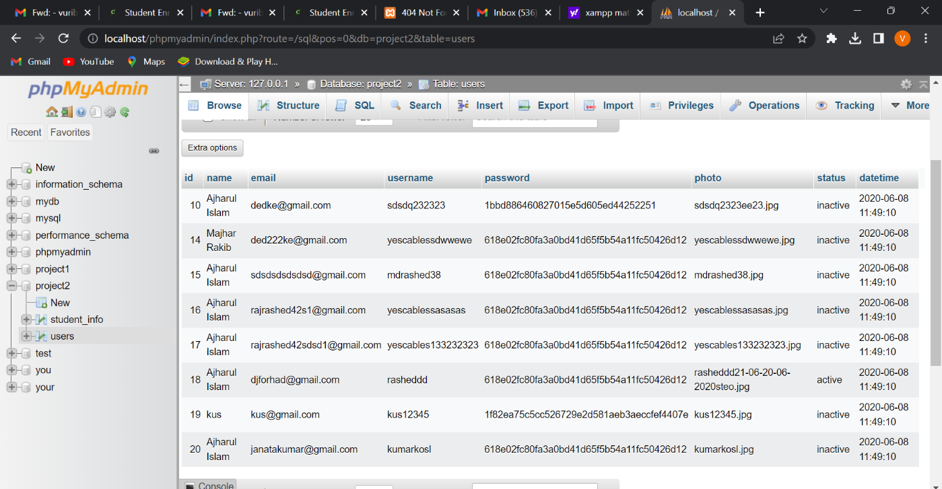

**Users table data**

* Now go to register file in admin in php file and change into active status.

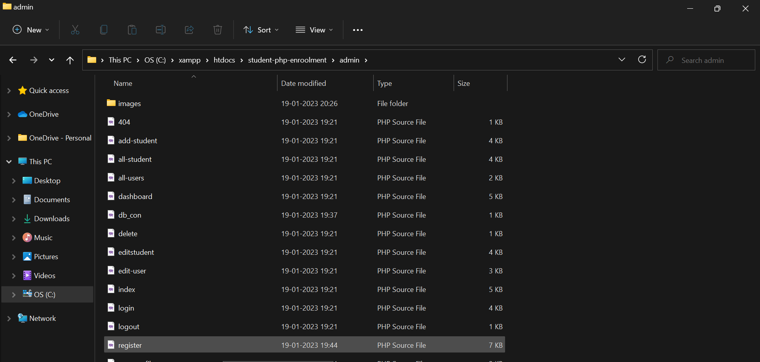

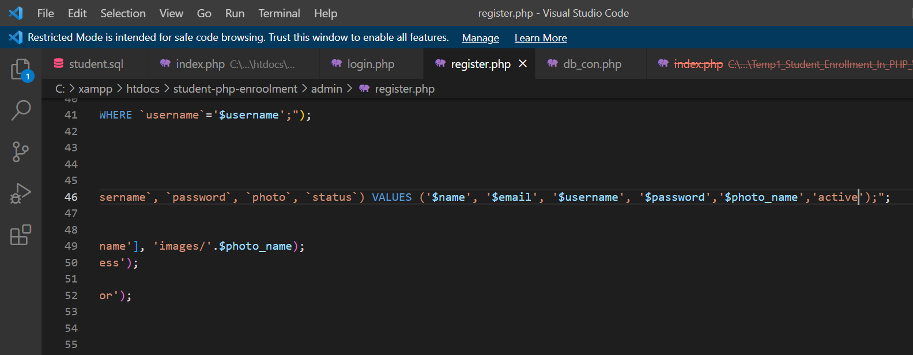

**Changing inactive to active**

* Once we are done with the code we can operate into localhost by clicking[**http://localhost//student-php-enrolling/index.php**](http://localhost//student-php-enrolling/index.php)
* **we** enter into a website called welcome to student management system .there we have login credentials
* choose class and rollno.
* whenever we fill this details we enter into our login in the database.

**Index.php**

**//Source Code:**

<?php require_once 'admin/db_con.php'; ?>

<!doctype html>

<html lang="en">

<head>

<!-- Required meta tags -->

<meta charset="utf-8">

<meta name="viewport" content="width=device-width, initial-scale=1, shrink-to-fit=no">

<!-- Bootstrap CSS -->

<link rel="stylesheet" href="css/bootstrap.min.css">

<link rel="stylesheet" href="https://cdnjs.cloudflare.com/ajax/libs/animate.css/4.0.0/animate.min.css"/>

<link rel="stylesheet" type="text/css" href="css/style.css">

<title>Hello, world!</title>

</head>

<body>

<div class="container"><br>

<a class="btn btn-primary float-right" href="admin/login.php">Login</a>

<h1 class="text-center">Welcome to Student Management System!</h1><br>

<div class="row">

<div class="col-md-4 offset-md-4">

<form method="POST">

<table class="text-center infotable">

<tr>

<th colspan="2">

<p class="text-center">Student Information</p>

</th>

</tr>

<tr>

<td>

<p>Choose Class</p>

</td>

<td>

<select class="form-control" name="choose">

<option value="">

Select

</option>

<option value="1st">

1St

</option>

<option value="2nd">

2nd

</option>

<option value="3rd">

3rd

</option>

<option value="4th">

4th

</option>

<option value="5th">

5th

</option>

</select>

</td>

</tr>

<tr>

<td>

<p><label for="roll">Roll No</label></p>

</td>

<td>

<input class="form-control" type="text" pattern="[0-9]{6}" id="roll" placeholder="Roll Num.." name="roll">

</td>

</tr>

<tr>

<td colspan="2" class="text-center">

<input class="btn btn-danger" type="submit" name="showinfo">

</td>

</tr>

</table>

</form>

</div>

</div>

<br>

<?php if (isset($_POST['showinfo'])) {

$choose= $_POST['choose'];

$roll = $_POST['roll'];

if (!empty($choose && $roll)) {

$query = mysqli_query($db_con,"SELECT * FROM `student_info` WHERE `roll`='$roll' AND `class`='$choose'");

if (!empty($row=mysqli_fetch_array($query))) {

if ($row['roll']==$roll && $choose==$row['class']) {

$stroll= $row['roll'];

$stname= $row['name'];

$stclass= $row['class'];

$city= $row['city'];

$photo= $row['photo'];

$pcontact= $row['pcontact'];

?>

<div class="row">

<div class="col-sm-6 offset-sm-3">

<table class="table table-bordered">

<tr>

<td rowspan="5"><h3>Student Info</h3><img class="img-thumbnail" src="admin/images/<?= isset($photo)?$photo:'';?>" width="250px"></td>

<td>Name</td>

<td><?= isset($stname)?$stname:'';?></td>

</tr>

<tr>

<td>Roll</td>

<td><?= isset($stroll)?$stroll:'';?></td>

</tr>

<tr>

<td>Class</td>

<td><?= isset($stclass)?$stclass:'';?></td>

</tr>

<tr>

<td>City</td>

<td><?= isset($city)?$city:'';?></td>

</tr>

<tr>

<td>Submit Date</td>

<td><?= isset($pcontact)?$pcontact:'';?></td>

</tr>

</table>

</div>

</div>

<?php

}else{

echo '<p style="color:red;">Please Input Valid Roll & Email</p>';

}

}else{

echo '<p style="color:red;">Your Input Doesn\'t Match!</p>';

}

}else{?>

<script type="text/javascript">alert("Data Not Found!");</script>

<?php }

}; ?>

</div>

<!-- Optional JavaScript -->

<!-- jQuery first, then Popper.js, then Bootstrap JS -->

<script src="js/jquery-3.5.1.min.js"></script>

<script src="js/bootstrap.min.js"></script>

</body>

</html>

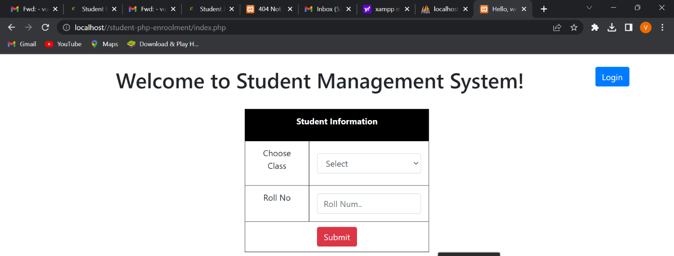

* for example we login to the credentials that are available in database
* choose class:1st and Rollno:444433

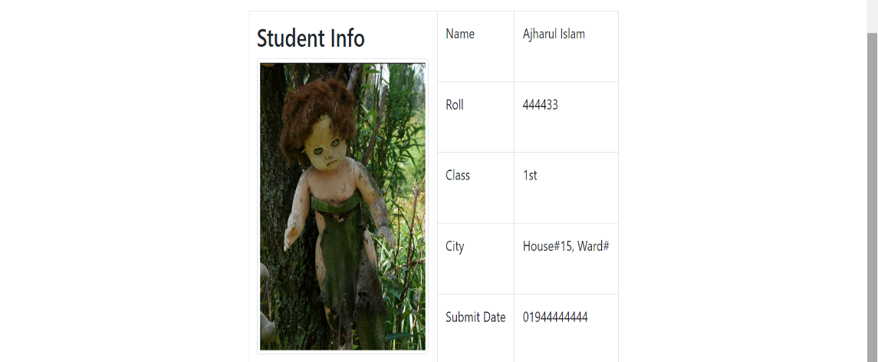

* if we are new to the system we can first create an account by clicking register button.

**Register.php**

**//Source Code:**

<?php require_once 'db_con.php';

session_start();

if (isset($_POST['register'])) {

$name = $_POST['name'];

$email = $_POST['email'];

$username = $_POST['username'];

$password = $_POST['password'];

$c_password = $_POST['c_password'];

$photo = explode('.', $_FILES['photo']['name']);

$photo= end($photo);

$photo_name= $username.'.'.$photo;

$input_error = array();

if (empty($name)) {

$input_error['name'] = "The Name Filed is Required";

}

if (empty($email)) {

$input_error['email'] = "The Email Filed is Required";

}

if (empty($username)) {

$input_error['username'] = "The UserName Filed is Required";

}

if (empty($password)) {

$input_error['password'] = "The Password Filed is Required";

}

if (empty($photo)) {

$input_error['photo'] = "The Photo Filed is Required";

}

if (!empty($password)) {

if ($c_password!==$password) {

$input_error['notmatch']="You Typed Wrong Password!";

}

}

if (count($input_error)==0) {

$check_email= mysqli_query($db_con,"SELECT * FROM `users` WHERE `email`='$email';");

if (mysqli_num_rows($check_email)==0) {

$check_username= mysqli_query($db_con,"SELECT * FROM `users` WHERE `username`='$username';");

if (mysqli_num_rows($check_username)==0) {

if (strlen($username)>7) {

if (strlen($password)>7) {

$password = sha1(md5($password));

$query = "INSERT INTO `users`(`name`, `email`, `username`, `password`, `photo`, `status`) VALUES ('$name', '$email', '$username', '$password','$photo_name','inactive');";

$result = mysqli_query($db_con,$query);

if ($result) {

move_uploaded_file($_FILES['photo']['tmp_name'], 'images/'.$photo_name);

header('Location: register.php?insert=sucess');

}else{

header('Location: register.php?insert=error');

}

}else{

$passlan="This password more than 8 charset";

}

}else{

$usernamelan= 'This username more than 8 charset';

}

}else{

$username_error="This username already exists!";

}

}else{

$email_error= "This email already exists";

}

}

}

?>

<!doctype html>

<html lang="en">

<head>

<!-- Required meta tags -->

<meta charset="utf-8">

<meta name="viewport" content="width=device-width, initial-scale=1, shrink-to-fit=no">

<!-- Bootstrap CSS -->

<link rel="stylesheet" href="../css/bootstrap.min.css">

<link rel="stylesheet" href="https://cdnjs.cloudflare.com/ajax/libs/animate.css/4.0.0/animate.min.css"/>

<link rel="stylesheet" type="text/css" href="../css/style.css">

<title>Hello, world!</title>

</head>

<body>

<div class="container"><br>

<h1 class="text-center">Register Users!</h1><hr><br>

<div class="d-flex justify-content-center">

<?php

if (isset($_GET['insert'])) {

if($_GET['insert']=='sucess'){ echo '<div role="alert" aria-live="assertive" aria-atomic="true" align="center" class="toast alert alert-success fade hide" data-delay="2000">Your Data Inserted!</div>';}

}

;?>

</div>

<div class="row animate__animated animate__pulse">

<div class="col-md-8 offset-md-2">

<form method="POST" enctype="multipart/form-data">

<div class="form-group row">

<div class="col-sm-6">

<input type="text" class="form-control" value="<?= isset($name)? $name:'' ?>" name="name" placeholder="Name" id="inputEmail3"><?= isset($input_error['name'])? '<label for="inputEmail3" class="error">'.$input_error['name'].'</label>':''; ?>

</div>

<div class="col-sm-6">

<input type="email" class="form-control" value="<?= isset($email)? $email:'' ?>" name="email" placeholder="Email" id="inputEmail3"><?= isset($input_error['email'])? '<label class="error">'.$input_error['email'].'</label>':''; ?>

<?= isset($email_error)? '<label class="error">'.$email_error.'</label>':''; ?>

</div>

</div>

<div class="form-group row">

<div class="col-sm-4">

<input type="text" name="username" value="<?= isset($username)? $username:'' ?>" class="form-control" id="inputPassword3" placeholder="Username"><?= isset($input_error['usrname'])? '<label class="error">'.$input_error['username'].'</label>':''; ?><?= isset($username_error)? '<label class="error">'.$username_error.'</label>':''; ?><?= isset($usernamelan)? '<label class="error">'.$usernamelan.'</label>':''; ?>

</div>

<div class="col-sm-4">

<input type="password" name="password" class="form-control" id="inputPassword3" placeholder="Password"><?= isset($input_error['password'])? '<label class="error">'.$input_error['password'].'</label>':''; ?> <?= isset($passlan)? '<label class="error">'.$passlan.'</label>':''; ?>

</div>

<div class="col-sm-4">

<input type="password" name="c_password" class="form-control" id="inputPassword3" placeholder="Confirm Password"><?= isset($input_error['notmatch'])? '<label class="error">'.$input_error['notmatch'].'</label>':''; ?> <?= isset($passlan)? '<label class="error">'.$passlan.'</label>':''; ?>

</div>

</div>

<div class="row">

<div class="col-sm-3"><label for="photo">Choose your photo</label></div>

<div class="col-sm-9">

<input type="file" id="photo" name="photo" class="form-control" id="inputPassword3" >

<br>

</div>

</div>

<div class="text-center">

<button type="submit" name="register" class="btn btn-danger">Register!</button>

</div>

</div>

</form>

</div>

</div>

<p>If you have account, you can <a href="login.php">Login</a> your account!</p>

</div>

<footer>

<p>Copyright &copy; 2016 to <?php echo date('Y') ?></p>

</footer>

<!-- Optional JavaScript -->

<!-- jQuery first, then Popper.js, then Bootstrap JS -->

<script src="../js/jquery-3.5.1.min.js"></script>

<script src="../js/bootstrap.min.js"></script>

<script type="text/javascript">

$('.toast').toast('show')

</script>

</body>

</html>

* 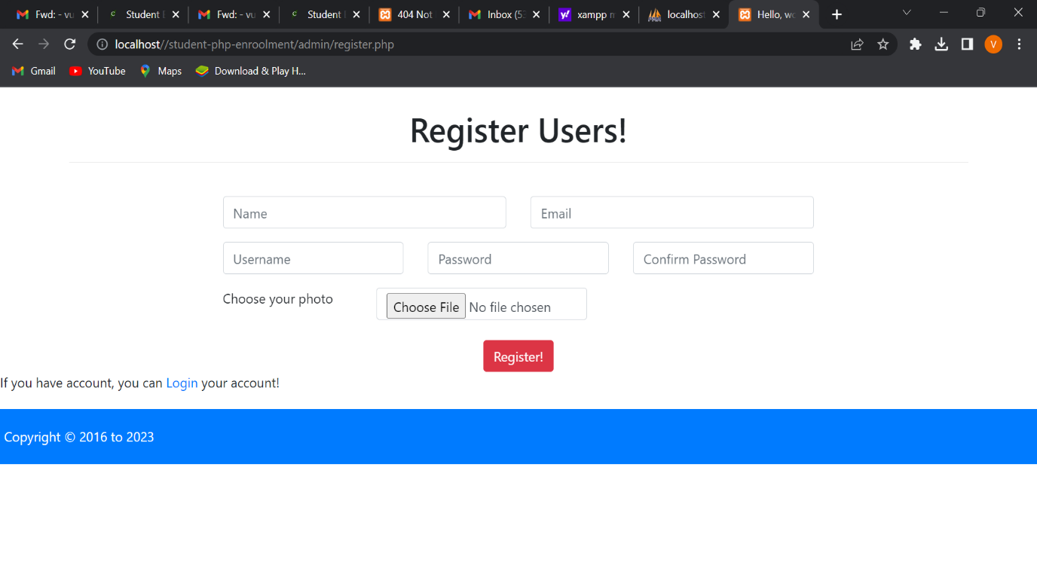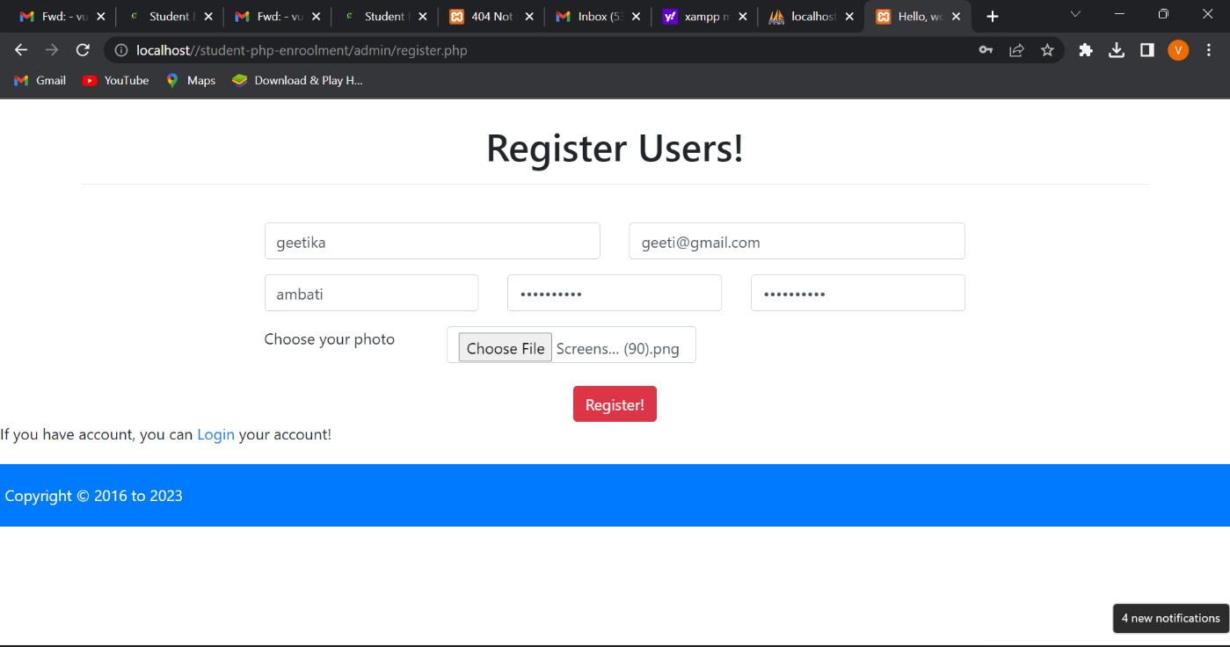
* we can fill out the details in registration form.

**Login.php**

**//Source Code:**

<?php require_once 'db_con.php';

session_start();

if(isset($_SESSION['user_login'])){

header('Location: index.php');

}

if (isset($_POST['login'])) {

$username= $_POST['username'];

$password= $_POST['password'];

$input_arr = array();

if (empty($username)) {

$input_arr['input_user_error']= "Username Is Required!";

}

if (empty($password)) {

$input_arr['input_pass_error']= "Password Is Required!";

}

if(count($input_arr)==0){

$query = "SELECT * FROM `users` WHERE `username` = '$username';";

$result = mysqli_query($db_con, $query);

if (mysqli_num_rows($result)==1) {

$row = mysqli_fetch_assoc($result);

if ($row['password']==sha1(md5($password))) {

if ($row['status']=='active') {

$_SESSION['user_login']=$username;

header('Location: index.php');

}else{

$status_inactive = "Your Status is inactive, please contact with admin or support!";

}

}else{

$worngpass= "This password Wrong!";

}

}else{

$usernameerr= "Username Not Found!";

}

}

}

?>

<!doctype html>

<html lang="en">

<head>

<!-- Required meta tags -->

<meta charset="utf-8">

<meta name="viewport" content="width=device-width, initial-scale=1, shrink-to-fit=no">

<!-- Bootstrap CSS -->

<link rel="stylesheet" href="../css/bootstrap.min.css">

<link rel="stylesheet" href="https://cdnjs.cloudflare.com/ajax/libs/animate.css/4.0.0/animate.min.css"/>

<link rel="stylesheet" type="text/css" href="../css/style.css">

<title>Hello, world!</title>

</head>

<body>

<div class="container"><br>

<h1 class="text-center">Login Users!</h1><hr><br>

<div class="d-flex justify-content-center">

<?php if(isset($usernameerr)){ ?> <div role="alert" aria-live="assertive" aria-atomic="true" align="center" class="toast alert alert-danger fade hide" data-delay="2000"><?php echo $usernameerr; ?></div><?php };?>

<?php if(isset($worngpass)){ ?> <div role="alert" aria-live="assertive" aria-atomic="true" align="center" class="toast alert alert-danger fade hide" data-delay="2000"><?php echo $worngpass; ?></div><?php };?>

<?php if(isset($status_inactive)){ ?> <div role="alert" aria-live="assertive" aria-atomic="true" align="center" class="toast alert alert-danger fade hide" data-delay="2000"><?php echo $status_inactive; ?></div><?php };?>

</div>

<div class="row animate__animated animate__pulse">

<div class="col-md-4 offset-md-4">

<form method="POST" action="">

<div class="form-group row">

<div class="col-sm-12">

<input type="text" class="form-control" name="username" value="<?= isset($username)? $username: ''; ?>" placeholder="Username" id="inputEmail3"> <?php echo isset($input_arr['input_user_error'])? '<label>'.$input_arr['input_user_error'].'</label>':''; ?>

</div>

</div>

<div class="form-group row">

<div class="col-sm-12">

<input type="password" name="password" class="form-control" id="inputPassword3" placeholder="Password"><label><?php echo isset($input_arr['input_pass_error'])? '<label>'.$input_arr['input_pass_error'].'</label>':''; ?>

</div>

</div>

<div class="text-center">

<button type="submit" name="login" class="btn btn-warning">Sign in</button>

</div>

<p>If you have don't user account, You can<a href="register.php"> Register Account!</a></p>

</div>

</form>

</div>

</div>

</div>

<!-- Optional JavaScript -->

<!-- jQuery first, then Popper.js, then Bootstrap JS -->

<script src="../js/jquery-3.5.1.min.js"></script>

<script src="../js/bootstrap.min.js"></script>

<script type="text/javascript">

$('.toast').toast('show')

</script>

</body>

</html>

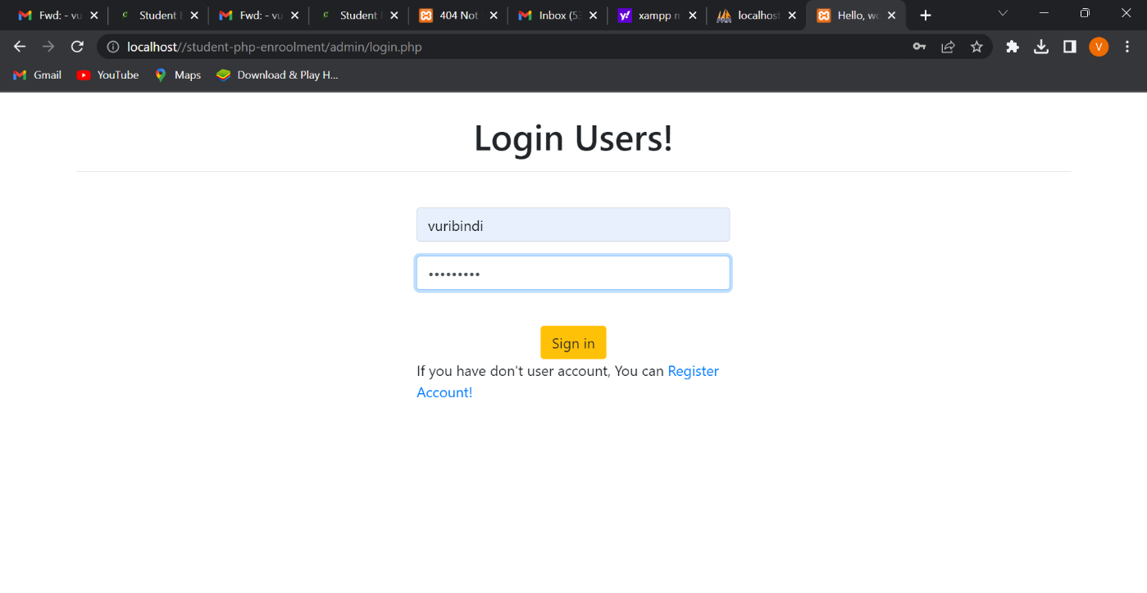

**Index.php**

**//Source Code:**

<?php require_once 'db_con.php';

session_start();

if (!isset($_SESSION['user_login'])) {

header('Location: login.php');

}

?>

<!doctype html>

<html lang="en">

<head>

<!-- Required meta tags -->

<meta charset="utf-8">

<meta name="viewport" content="width=device-width, initial-scale=1, shrink-to-fit=no">

<!-- Bootstrap CSS -->

<link rel="stylesheet" href="../css/bootstrap.min.css">

<link rel="stylesheet" href="../css/dataTables.bootstrap4.min.css">

<link rel="stylesheet" href="../css/fontawesome.min.css">

<link rel="stylesheet" href="../css/solid.min.css">

<link rel="stylesheet" href="https://cdnjs.cloudflare.com/ajax/libs/animate.css/4.0.0/animate.min.css"/>

<link rel="stylesheet" type="text/css" href="../css/style.css">

<!-- Optional JavaScript -->

<!-- jQuery first, then Popper.js, then Bootstrap JS -->

<script src="../js/jquery-3.5.1.min.js"></script>

<script src="../js/bootstrap.min.js"></script>

<script src="../js/jquery.dataTables.min.js"></script>

<script src="../js/dataTables.bootstrap4.min.js"></script>

<script src="../js/fontawesome.min.js"></script>

<script src="../js/script.js"></script>

<title>Admin Deshboard</title>

</head>

<body>

<nav class="navbar navbar-expand-lg navbar-dark bg-dark">

<a class="navbar-brand" href="index.php"><i class="fas fa-chart-line fa-3x"></i></a>

<button class="navbar-toggler" type="button" data-toggle="collapse" data-target="#navbarSupportedContent" aria-controls="navbarSupportedContent" aria-expanded="false" aria-label="Toggle navigation">

<span class="navbar-toggler-icon"></span>

</button>

<div class="navbar-collapse collapse justify-content-end" id="navbarSupportedContent">

<?php $showuser = $_SESSION['user_login']; $haha = mysqli_query($db_con,"SELECT * FROM `users` WHERE `username`='$showuser';"); $showrow=mysqli_fetch_array($haha); ?>

<ul class="nav navbar-nav ">

<li class="nav-item"><a class="nav-link" href="index.php?page=user-profile"><i class="fa fa-user"></i> Welcome <?php echo $showrow['name']; ?>!</a></li>

<li class="nav-item"><a class="nav-link" href="index.php?page=add-student"><i class="fa fa-user-plus"></i> Add Stuennt</a></li>

<li class="nav-item"><a class="nav-link" href="index.php?page=user-profile"><i class="fa fa-user"></i> Profile</a></li>

<li class="nav-item"><a class="nav-link" href="logout.php"><i class="fa fa-power-off"></i> Logout</a></li>

</ul>

</div>

</nav>

<br>

<div class="container">

<div class="row">

<div class="col-md-3">

<div class="list-group">

<a href="index.php?page=dashboard" class="list-group-item list-group-item-action active">

<i class="fas fa-tachometer-alt"></i> Dashboard

</a>

<a href="index.php?page=add-student" class="list-group-item list-group-item-action"><i class="fa fa-user-plus"></i> Add Student</a>

<a href="index.php?page=all-student" class="list-group-item list-group-item-action"><i class="fa fa-users"></i> All Students</a>

<a href="index.php?page=all-users" class="list-group-item list-group-item-action"><i class="fa fa-users"></i> All Users</a>

<a href="index.php?page=user-profile" class="list-group-item list-group-item-action"><i class="fa fa-user"></i> User Profile</a>

</div>

</div>

<div class="col-md-9">

<div class="content">

<?php

if (isset($_GET['page'])) {

$page = $_GET['page'].'.php';

}else{

$page = 'dashboard.php';

}

if (file_exists($page)) {

require_once $page;

}else{

require_once '404.php';

}

?>

</div>

</div>

</div>

</div>

<div class="clearfix"></div>

<footer>

<div class="container">

<p>Copyright &copy; 2016 to <?php echo date('Y') ?></p>

</div>

</footer>

<script type="text/javascript">

jQuery('.toast').toast('show');

</script>

</body>

</html>

* Then we can login into our account in database.

**Dashboard.php**

**//Source Code:**

<?php

$corepage = explode('/', $_SERVER['PHP_SELF']);

$corepage = end($corepage);

if ($corepage!=='index.php') {

if ($corepage==$corepage) {

$corepage = explode('.', $corepage);

header('Location: index.php?page='.$corepage[0]);

}

}

?>

<h1><a href="index.php"><i class="fas fa-tachometer-alt"></i> Dashboard</a> <small>Satistics Overview</small></h1>

<nav aria-label="breadcrumb">

<ol class="breadcrumb">

<li class="breadcrumb-item active" aria-current="page"><i class="fas fa-user"></i> Dashboard</li>

</ol>

</nav>

<div class="row student">

<div class="col-sm-4">

<div class="card text-white bg-primary mb-3">

<div class="card-header">

<div class="row">

<div class="col-sm-4">

<i class="fa fa-users fa-3x"></i>

</div>

<div class="col-sm-8">

<div class="float-sm-right">&nbsp;<span style="font-size: 30px"><?php $stu=mysqli_query($db_con,'SELECT * FROM `student_info`'); $stu= mysqli_num_rows($stu); echo $stu; ?></span></div>

<div class="clearfix"></div>

<div class="float-sm-right">Total Students</div>

</div>

</div>

</div>

<div class="list-group-item-primary list-group-item list-group-item-action">

<div class="row">

<div class="col-sm-8">

<p class="">All Students</p>

</div>

<div class="col-sm-4">

<a href="all-student.php"><i class="fa fa-arrow-right float-sm-right"></i></a>

</div>

</div>

</div>

</div>

</div>

<div class="col-sm-4">

<div class="card text-white bg-info mb-3">

<div class="card-header">

<div class="row">

<div class="col-sm-4">

<i class="fa fa-users fa-3x"></i>

</div>

<div class="col-sm-8">

<div class="float-sm-right">&nbsp;<span style="font-size: 30px"><?php $tusers=mysqli_query($db_con,'SELECT * FROM `users`'); $tusers= mysqli_num_rows($tusers); echo $tusers; ?></span></div>

<div class="clearfix"></div>

<div class="float-sm-right">Total Users</div>

</div>

</div>

</div>

<div class="list-group-item-primary list-group-item list-group-item-action">

<a href="index.php?page=all-users">

<div class="row">

<div class="col-sm-8">

<p class="">All Users</p>

</div>

<div class="col-sm-4">

<i class="fa fa-arrow-right float-sm-right"></i>

</div>

</div>

</a>

</div>

</div>

</div>

<div class="col-sm-4">

<div class="card text-white bg-warning mb-3">

<div class="card-header">

<div class="row">

<?php $usernameshow = $_SESSION['user_login']; $userspro = mysqli_query($db_con,"SELECT * FROM `users` WHERE `username`='$usernameshow';"); $userrow=mysqli_fetch_array($userspro); ?>

<div class="col-sm-6">

<img class="showimg" src="images/<?php echo $userrow['photo']; ?>">

<div style="font-size: 20px"><?php echo ucwords($userrow['name']); ?></div>

</div>

<div class="col-sm-6">

<div class="clearfix"></div>

<div class="float-sm-right">Welcome!</div>

</div>

</div>

</div>

<div class="list-group-item-primary list-group-item list-group-item-action">

<a href="index.php?page=user-profile">

<div class="row">

<div class="col-sm-8">

<p class="">Your Profile</p>

</div>

<div class="col-sm-4">

<i class="fa fa-arrow-right float-sm-right"></i>

</div>

</div>

</a>

</div>

</div>

</div>

</div>

<hr>

<h3>New Students</h3>

<table class="table table-striped table-hover table-bordered" id="data">

<thead class="thead-dark">

<tr>

<th scope="col">SL</th>

<th scope="col">Name</th>

<th scope="col">Roll</th>

<th scope="col">City</th>

<th scope="col">Contact</th>

<th scope="col">Photo</th>

</tr>

</thead>

<tbody>

<?php

$query=mysqli_query($db_con,'SELECT * FROM `student_info` ORDER BY `student_info`.`datetime` DESC;');

$i=1;

while ($result = mysqli_fetch_array($query)) { ?>

<tr>

<?php

echo '<td>'.$i.'</td>

<td>'.ucwords($result['name']).'</td>

<td>'.$result['roll'].'</td>

<td>'.ucwords($result['city']).'</td>

<td>'.$result['pcontact'].'</td>

<td><img src="images/'.$result['photo'].'" height="50px"></td>';?>

</tr>

<?php $i++;} ?>

</tbody>

</table>

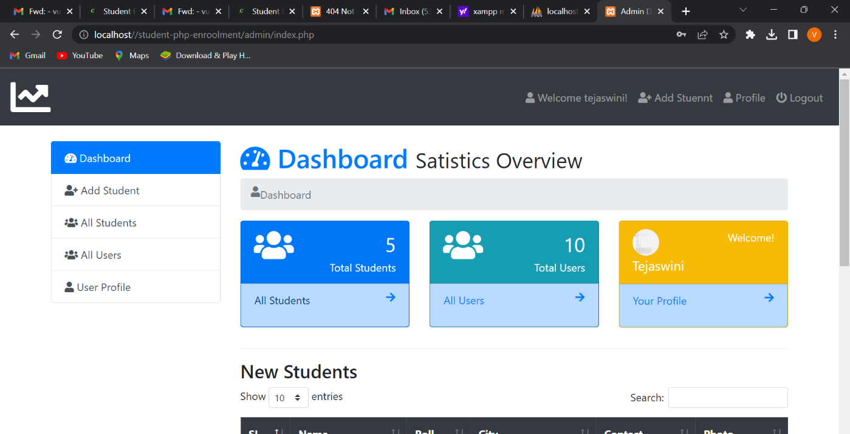

* Then we can overview into our account.
* And we can check our details in our account.

**User_profile.php**

**//Source Code:**

<?php

$user= $_SESSION['user_login'];

$corepage = explode('/', $_SERVER['PHP_SELF']);

$corepage = end($corepage);

if ($corepage!=='index.php') {

if ($corepage==$corepage) {

$corepage = explode('.', $corepage);

header('Location: index.php?page='.$corepage[0]);

}

}

?>

<h1 class="text-primary"><i class="fas fa-user"></i> User Profile</h1>

<nav aria-label="breadcrumb">

<ol class="breadcrumb">

<li class="breadcrumb-item" aria-current="page"><a href="index.php">Dashboard </a></li>

<li class="breadcrumb-item active" aria-current="page">User Profile</li>

</ol>

</nav>

<?php

$query = mysqli_query($db_con, "SELECT * FROM `users` WHERE `username` ='$user';");

$row = mysqli_fetch_array($query);

?>

<div class="row">

<div class="col-sm-6">

<table class="table table-bordered">

<tr>

<td>User ID</td>

<td><?php echo $row['id']; ?></td>

</tr>

<tr>

<td>Name</td>

<td><?php echo ucwords($row['name']); ?></td>

</tr>

<tr>

<td>Email</td>

<td><?php echo $row['email']; ?></td>

</tr>

<tr>

<td>Username</td>

<td><?php echo ucwords($row['username']); ?></td>

</tr>

<tr>

<td>Status</td>

<td><?php echo ucwords($row['status']); ?></td>

</tr>

<tr>

<td>Register Date</td>

<td><?php echo $row['datetime']; ?></td>

</tr>

</table>

<a class="btn btn-warning pull-right" href="index.php?page=edit-user&id=<?php echo base64_encode($row['id']); ?>">Edit Profile</a>

</div>

<div class="col-sm-6">

<h3>Profile Picture</h3>

<a href="images/<?php echo $row['photo']; ?>">

<img class="img-thumbnail" id="imguser" src="images/<?php echo $row['photo']; ?>" width="200px">

</a>

<?php

if (isset($_POST['upphoto'])) {

unlink('images/'.$row['photo']);

$photofile = $_FILES['userphoto']['tmp_name'];

$upphoto = $user.date('s-m-y-m-Y').$_FILES['userphoto']['name'];

if (mysqli_query($db_con, "UPDATE `users` SET `photo` = '$upphoto' WHERE `users`.`username` = '$user';")) {

move_uploaded_file($photofile, 'images/'.$upphoto);

}else{

echo "Profile Picture Not Uploaded";

}

}

?><br>

<form method="POST" enctype="multipart/form-data">

<input type="file" name="userphoto" required="" id="photo"><br>

<input class="btn btn-info" type="submit" name="upphoto" value="Upload Photo">

</form>

</div>

</div>

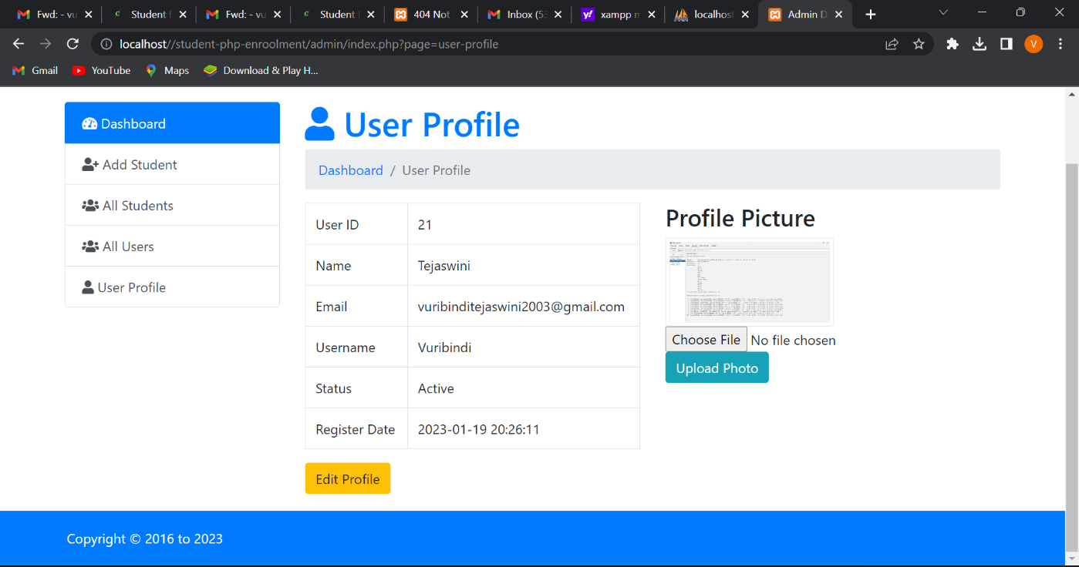

**Add_student.php**

**//Source Code:**

<?php

$corepage = explode('/', $_SERVER['PHP_SELF']);

$corepage = end($corepage);

if ($corepage!=='index.php') {

if ($corepage==$corepage) {

$corepage = explode('.', $corepage);

header('Location: index.php?page='.$corepage[0]);

}

}

if (isset($_POST['addstudent'])) {

$name = $_POST['name'];

$roll = $_POST['roll'];

$address = $_POST['address'];

$pcontact = $_POST['pcontact'];

$class = $_POST['class'];

$photo = explode('.', $_FILES['photo']['name']);

$photo = end($photo);

$photo = $roll.date('Y-m-d-m-s').'.'.$photo;

$query = "INSERT INTO `student_info`(`name`, `roll`, `class`, `city`, `pcontact`, `photo`) VALUES ('$name', '$roll', '$class', '$address', '$pcontact','$photo');";

if (mysqli_query($db_con,$query)) {

$datainsert['insertsucess'] = '<p style="color: green;">Student Inserted!</p>';

move_uploaded_file($_FILES['photo']['tmp_name'], 'images/'.$photo);

}else{

$datainsert['inserterror']= '<p style="color: red;">Student Not Inserted, please input right informations!</p>';

}

}

?>

<h1 class="text-primary"><i class="fas fa-user-plus"></i> Add Student<small class="text-warning"> Add New Student!</small></h1>

<nav aria-label="breadcrumb">

<ol class="breadcrumb">

<li class="breadcrumb-item" aria-current="page"><a href="index.php">Dashboard </a></li>

<li class="breadcrumb-item active" aria-current="page">Add Student</li>

</ol>

</nav>

<div class="row">

<div class="col-sm-6">

<?php if (isset($datainsert)) {?>

<div role="alert" aria-live="assertive" aria-atomic="true" class="toast fade" data-autohide="true" data-animation="true" data-delay="2000">

<div class="toast-header">

<strong class="mr-auto">Student Insert Alert</strong>

<small><?php echo date('d-M-Y'); ?></small>

<button type="button" class="ml-2 mb-1 close" data-dismiss="toast" aria-label="Close">

<span aria-hidden="true">&times;</span>

</button>

</div>

<div class="toast-body">

<?php

if (isset($datainsert['insertsucess'])) {

echo $datainsert['insertsucess'];

}

if (isset($datainsert['inserterror'])) {

echo $datainsert['inserterror'];

}

?>

</div>

</div>

<?php } ?>

<form enctype="multipart/form-data" method="POST" action="">

<div class="form-group">

<label for="name">Student Name</label>

<input name="name" type="text" class="form-control" id="name" value="<?= isset($name)? $name: '' ; ?>" required="">

</div>

<div class="form-group">

<label for="roll">Student Roll</label>

<input name="roll" type="text" value="<?= isset($roll)? $roll: '' ; ?>" class="form-control" pattern="[0-9]{6}" id="roll" required="">

</div>

<div class="form-group">

<label for="address">Student Address</label>

<input name="address" type="text" value="<?= isset($address)? $address: '' ; ?>" class="form-control" id="address" required="">

</div>

<div class="form-group">

<label for="pcontact">Parant Contact NO</label>

<input name="pcontact" type="text" class="form-control" id="pcontact" pattern="01[5|6|7|8|9][0-9]{8}" value="<?= isset($pcontact)? $pcontact: '' ; ?>" placeholder="01........." required="">

</div>

<div class="form-group">

<label for="class">Student Class</label>

<select name="class" class="form-control" id="class" required="">

<option>Select</option>

<option value="1st">1st</option>

<option value="2nd">2nd</option>

<option value="3rd">3rd</option>

<option value="4th">4th</option>

<option value="5th">5th</option>

</select>

</div>

<div class="form-group">

<label for="photo">Student Photo</label>

<input name="photo" type="file" class="form-control" id="photo" required="">

</div>

<div class="form-group text-center">

<input name="addstudent" value="Add Student" type="submit" class="btn btn-danger">

</div>

</form>

</div>

</div>

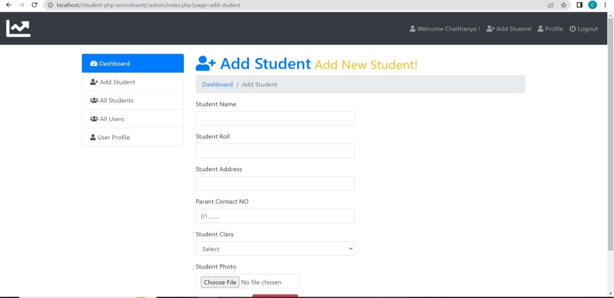

**All_students.php**

**//Source Code:**

<?php

$corepage = explode('/', $_SERVER['PHP_SELF']);

$corepage = end($corepage);

if ($corepage!=='index.php') {

if ($corepage==$corepage) {

$corepage = explode('.', $corepage);

header('Location: index.php?page='.$corepage[0]);

}

}

?>

<h1 class="text-primary"><i class="fas fa-users"></i> All Students<small class="text-warning"> All Students List!</small></h1>

<nav aria-label="breadcrumb">

<ol class="breadcrumb">

<li class="breadcrumb-item" aria-current="page"><a href="index.php">Dashboard </a></li>

<li class="breadcrumb-item active" aria-current="page">All Students</li>

</ol>

</nav>

<?php if(isset($_GET['delete']) || isset($_GET['edit'])) {?>

<div role="alert" aria-live="assertive" aria-atomic="true" class="toast fade" data-autohide="true" data-animation="true" data-delay="2000">

<div class="toast-header">

<strong class="mr-auto">Student Insert Alert</strong>

<small><?php echo date('d-M-Y'); ?></small>

<button type="button" class="ml-2 mb-1 close" data-dismiss="toast" aria-label="Close">

<span aria-hidden="true">&times;</span>

</button>

</div>

<div class="toast-body">

<?php

if (isset($_GET['delete'])) {

if ($_GET['delete']=='success') {

echo "<p style='color: green; font-weight: bold;'>Student Deleted Successfully!</p>";

}

}

if (isset($_GET['delete'])) {

if ($_GET['delete']=='error') {

echo "<p style='color: red'; font-weight: bold;>Student Not Deleted!</p>";

}

}

if (isset($_GET['edit'])) {

if ($_GET['edit']=='success') {

echo "<p style='color: green; font-weight: bold; '>Student Edited Successfully!</p>";

}

}

if (isset($_GET['edit'])) {

if ($_GET['edit']=='error') {

echo "<p style='color: red; font-weight: bold;'>Student Not Edited!</p>";

}

}

?>

</div>

</div>

<?php } ?>

<table class="table table-striped table-hover table-bordered" id="data">

<thead class="thead-dark">

<tr>

<th scope="col">SL</th>

<th scope="col">Name</th>

<th scope="col">Roll</th>

<th scope="col">City</th>

<th scope="col">Contact</th>

<th scope="col">Photo</th>

<th scope="col">Action</th>

</tr>

</thead>

<tbody>

<?php

$query=mysqli_query($db_con,'SELECT * FROM `student_info` ORDER BY `student_info`.`datetime` DESC;');

$i=1;

while ($result = mysqli_fetch_array($query)) { ?>

<tr>

<?php

echo '<td>'.$i.'</td>

<td>'.ucwords($result['name']).'</td>

<td>'.$result['roll'].'</td>

<td>'.ucwords($result['city']).'</td>

<td>'.$result['pcontact'].'</td>

<td><img src="images/'.$result['photo'].'" height="50px"></td>

<td>

<a class="btn btn-xs btn-warning" href="index.php?page=editstudent&id='.base64_encode($result['id']).'&photo='.base64_encode($result['photo']).'">

<i class="fa fa-edit"></i></a>

&nbsp; <a class="btn btn-xs btn-danger" onclick="javascript:confirmationDelete($(this));return false;" href="index.php?page=delete&id='.base64_encode($result['id']).'&photo='.base64_encode($result['photo']).'">

<i class="fas fa-trash-alt"></i></a></td>';?>

</tr>

<?php $i++;} ?>

</tbody>

</table>

<script type="text/javascript">

function confirmationDelete(anchor)

{

var conf = confirm('Are you sure want to delete this record?');

if(conf)

window.location=anchor.attr("href");

}

</script>

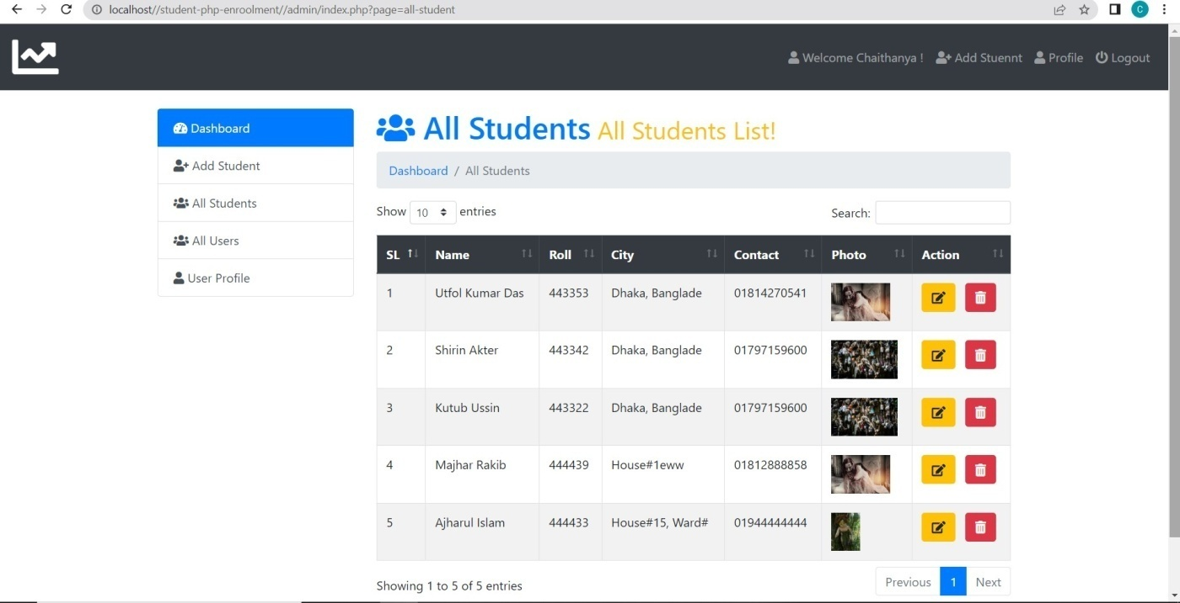

**All_users.php**

**//Source Code:**

<?php

$corepage = explode('/', $_SERVER['PHP_SELF']);

$corepage = end($corepage);

if ($corepage!=='index.php') {

if ($corepage==$corepage) {

$corepage = explode('.', $corepage);

header('Location: index.php?page='.$corepage[0]);

}

}

?>

<h1 class="text-primary"><i class="fas fa-users"></i> All Users<small class="text-warning"> All Users List!</small></h1>

<nav aria-label="breadcrumb">

<ol class="breadcrumb">

<li class="breadcrumb-item" aria-current="page"><a href="index.php">Dashboard </a></li>

<li class="breadcrumb-item active" aria-current="page">All Users</li>

</ol>

</nav>

<table class="table table-striped table-hover table-bordered" id="data">

<thead class="thead-dark">

<tr>

<th scope="col">SL</th>

<th scope="col">Name</th>

<th scope="col">Email</th>

<th scope="col">Username</th>

<th scope="col">Photo</th>

<th scope="col">Status</th>

</tr>

</thead>

<tbody>

<?php

$query=mysqli_query($db_con,'SELECT * FROM `users`');

$i=1;

while ($result = mysqli_fetch_array($query)) { ?>

<tr>

<?php

echo '<td>'.$i.'</td>

<td>'.ucwords($result['name']).'</td>

<td>'.$result['email'].'</td>

<td>'.ucwords($result['username']).'</td>

<td><img src="images/'.$result['photo'].'" height="50px"></td>

<td>'.$result['status'].'</td>';?>

</tr>

<?php $i++;} ?>

</tbody>

</table>

<script type="text/javascript">

function confirmationDelete(anchor)

{

var conf = confirm('Are you sure want to delete this record?');

if(conf)

window.location=anchor.attr("href");

}

</script>

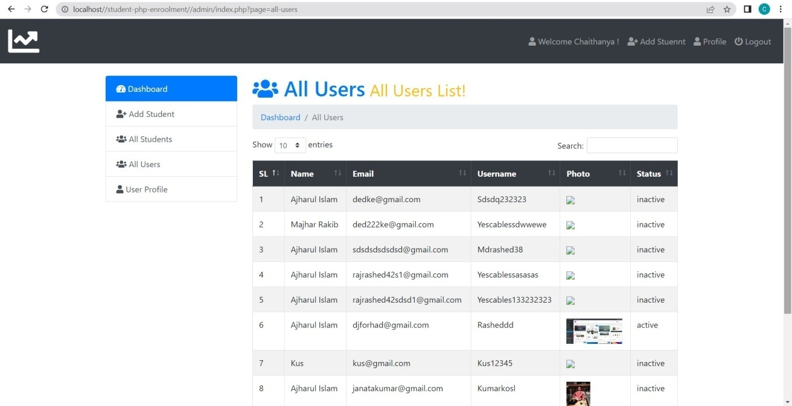

**Conclusion:**

We are creating a database and storing the student details by using php.This project main aim was to have a login credentials for every student who are studying in the university.This portal makes an easy access for them to check their results and attendance ,performance.By using php it makes easy for us to develop this project and made it successful.

**Source:**

**1.Php for the web _-larryullman**

**2.Php and Mysqlwebdevelopment-Luke welling**

**3.php and mysql-Mike mc Grath**